ROBUST ARTIFICIAL PANCREAS SYSTEM

CONTROLER FOR TYPE - 1 DIABETES PATIENTS

Stephan Kolontay

CTEC3451: Development Project

Professor Dr. Archie Khuman

De Montfort University, Leicester

13/01/2022

Table of Contents

Abstract 1

Introduction 1

Literature Review 2

Implications for Prevention and Treatment of Type-1 Diabetes 2

Implications for Management in The Era of Continuous Glucose Monitoring 2

Availability and Cost of Insulin 3

Standards for Managing Blood Sugar Levels in Diabetes 3

Dual Hormone Therapy Alternative 4

Feasibility of Artificial Pancreas Systems 5

Conclusion 5

Functional Requirements 6

System Users 6

Functionality 7

Use Cases 11

Test Plan 14

Testing Strategy 14

Functional Testing 15

Performance Testing 15

System Design 17

UML Diagram 17

App Design 17

APSC Design 18

Implementation Report 20

Bibliography 20

Appendices 23

# Abstract

This report discusses the development of a closed-loop artificial pancreas system controller system that utilizes artificial intelligence to assist patients with type-1 diabetes managing their condition. This technology allows for communication between continuous glucose monitor and an insulin pump without need for patient input, potentially paving the way for a new generation of self-managing, autonomous health-controllers.  This research aims to investigate existing bio-technological diabetes treatment options by reviewing and analyzing the current market for standard diabetes controllers to derive a self-interpreted prototype. In addition, due to ethical concerns the system will be ran and tested in a simulation, utilizing mathematical interpretation of the biochemical processes within human pancreas.

# Introduction

Type 1 diabetes is a chronic condition that affects the body's ability to produce insulin, a hormone that helps regulate blood sugar levels. Without insulin, the body is unable to properly process glucose, leading to high blood sugar levels that can have serious health consequences. Diabetes have a long history dating back to ancient civilizations. The ancient Egyptians were among the first to describe clinical features similar to diabetes mellitus, and the term "diabetes" was coined by Araetus of Cappodocia in the 2nd century AD. In the modern era, the history of diabetes has been closely tied to the emergence of experimental medicine, with significant milestones.

While there is currently no known cure for type 1 diabetes, it can be managed through a combination of insulin therapy, diet, and regular physical activity. However, these management methods can be difficult for some individuals to adhere to, leading to a high risk of complications such as blindness, kidney failure, heart attacks, stroke, and amputation. In order to address these challenges and improve the lives of individuals with type 1 diabetes, researchers have been working on the development of an artificial pancreas system controller. This system aims to automate the insulin delivery process and better regulate blood sugar levels through the use of a continuous glucose monitor, and AI-powered insulin controller. However, due to ethical considerations and hardware limitations, this project will focus specifically on the development of software for the artificial pancreas system controller.

# Literature Review

## Implications for Prevention and Treatment of Type-1 Diabetes

In Atkinson et al., 2015 the historical model of Type 1 Diabetes Pathogenesis, proposed by Dr. George Eisenbarth in 1986 portrays type 1 diabetes as a T cell-mediated autoimmune disease involving the specific destruction of insulin-producing pancreatic β-cells. The model suggests that persons destined to develop type 1 diabetes are assumed to begin life with a full cadre of β-cells, and an environmental trigger initiates a process involving the recruitment of antigen-presenting cells which sequester self-antigens released by injured β-cells and presented to autoreactive T cells. This leads to the migration of self-reactive T cells to islets, mediating β-cell killing and promoting further inflammation.

The text also mentions that recent observations have challenged multiple aspects of this long-standing model. These studies have limitations, such as analyzing peripheral blood rather than the site of β-cell destruction, and not considering the effects of aging, diet, immune cell metabolism, microbial pathogens, microbiomes, and epigenetic changes on the immune response. Recent studies of human pancreas and other tissues obtained from organ donors with or at risk for type 1 diabetes, made possible through the efforts of the Belgian Beta Cell Bank and the JDRF Network for Pancreatic Organ Donors with Diabetes (nPOD) program.

While this concept still forms the prevailing intellectual dogma for the majority of individuals associated with diabetes care and research today, a series of recent observations has challenged multiple aspects of this long-standing model. Many of these evolving concepts will be presented in this Perspective, with a discussion of how our understanding of models of type 1 diabetes pathogenesis has and will likely continue to evolve as it relates to attempts seeking to prevent and/or reverse the disorder.

## Implications for Management in The Era of Continuous Glucose Monitoring

Continuous glucose monitoring highlights the complexity of postprandial glucose patterns in type 1 diabetes, pointing to the limitations of current approaches to mealtime insulin dosing that are based primarily on carbohydrate counting. "Currently, carbohydrates are considered the predominant macronutrient affecting postprandial glucose control and the primary determinant for calculating mealtime insulin doses in type 1 diabetes" (Bell et al., 2015).

A systematic review was conducted to identify research on the effects of dietary fat, protein, and glycemic index (GI) on acute postprandial glucose control in type 1 diabetes and prandial insulin dosing strategies for these dietary factors. The studies indicated that all dietary factors modify postprandial glycemia and late postprandial hyperglycemia was the predominant effect of dietary fat. The findings of the studies have important implications for clinical practice and patient education and point to the need for research focused on the development of new insulin dosing algorithms based on meal composition rather than on carbohydrate content alone.

## Availability and Cost of Insulin

“The average list price of insulin has skyrocketed in recent years, nearly tripling between 2002 and 2013” (Cefalu et al., 2018). The current pricing system, which includes rebates and discounts, encourages high list prices, with each intermediary in the insulin supply chain (wholesalers, PBMs, pharmacies) profiting from the increases.

There is a lack of transparency throughout the insulin supply chain, making it difficult to understand how the dollars flow and how much each intermediary profits. PBMs have significant market power and negotiate rebates using formulary placement as leverage. This can lead to formulary exclusions and changes, which can negatively impact patient care and increase costs for people with diabetes. Additionally, the regulatory framework for developing and approving biosimilar insulins is burdensome, leading to a lack of options and high prices. Prescribing patterns also favor newer, more expensive insulins over older, cheaper options like human insulin. These issues have serious financial and health consequences for people with diabetes.

## Standards for Managing Blood Sugar Levels in Diabetes

“The American Diabetes Association (ADA) “Standards of Care in Diabetes” includes the ADA’s current clinical practice recommendations and is intended to provide the components of diabetes care, general treatment goals and guidelines, and tools to evaluate quality of care.” (ElSayed et al., 2022). The ADA recommends a goal of less than 7% A1C for many non-pregnant adults without significant hypoglycemia. If using an ambulatory glucose profile or glucose management indicator to assess glycemia, a goal of greater than 70% time in range with less than 4% time below range and less than 54 mg/dL is recommended for many non-pregnant adults. For those with frailty or at high risk of hypoglycemia, a target of greater than 50% time in range with less than 1% time below range is recommended.

Lower A1C goals may be appropriate for patients with limited life expectancy or where the harms of treatment outweigh the benefits. Health care professionals should consider de-intensifying therapy to reduce the risk of hypoglycemia in patients with overly stringent A1C targets. Glycemic targets should be reassessed based on individual criteria and reviewed at every encounter. Hypoglycemia should be investigated and treated as necessary, and awareness should be raised using validated tools. Glucose is the preferred treatment for conscious individuals with blood glucose less than 70 mg/dL and glucagon should be prescribed for those at increased risk of severe hypoglycemia.

Hypoglycemia unawareness or severe episodes should trigger education and adjustments to the treatment plan to decrease future risk. Insulin-treated patients with hypoglycemia unawareness should raise their glycemic targets to avoid hypoglycemia for several weeks to reverse unawareness and reduce risk of future episodes. Cognitive function should be regularly assessed, and vigilance should be increased for hypoglycemia if cognitive impairment is found.

## Dual Hormone Therapy Alternative

“The advantage of the insulin-and-glucagon artificial pancreas is based on the rapid effect of subcutaneous glucagon delivery in preventing hypoglycemia compared to suspension of insulin delivery. In short-term studies, the dual-hormone artificial pancreas reduced daytime hypoglycemia, especially during exercise, compared to the insulin-alone artificial pancreas, but the insulin-alone system seemed sufficient in eliminating nocturnal hypoglycemia.” (Haidar, 2019). The dual-hormone artificial pancreas is a promising technology, but it comes with some practical considerations. It requires dual-chamber pumps and two infusion sites, which can be a limitation for younger or smaller patients.

Current glucagon formulations are not stable for continuous pump use, but alternative formulations are under development. The safety of long-term low doses of novel glucagon formulations needs to be established before approval by the FDA. The dual-hormone artificial pancreas is more potent in preventing hypoglycemia than the insulin-alone artificial pancreas, especially during times of rapidly changing glucose levels such as during exercise. It may also lead to lower A1C levels, but more studies are needed to confirm this.

## Feasibility of Artificial Pancreas Systems

“Artificial pancreas (AP) systems, a long-sought quest to replicate mechanically islet physiology that is lost in diabetes, are reaching the clinic, and the potential of automating insulin delivery is about to be realized.” (Kowalski, 2015).

The unmet medical need in diabetes is significant. Despite extensive knowledge of the damage of hyperglycemia and the passage of 23 years since the Diabetes Control and Complications. Trial, glycemic control levels in Europe remain suboptimal (Kulzer et al., 2022). Current clinical evidence, including data from the T1D Exchange registry, paints a picture that is full of opportunity for significant improvement across all diabetes outcomes measured. A1C levels remain elevated, hypoglycemia is frequent, diabetic ketoacidosis rates remain elevated, time in range is poor, and patients still suffer from significantly elevated levels of anxiety, depression, and other psychosocial issues.

The question arises as to why these goals are not being achieved. It is clear that the tools today do not easily allow for the normalization of glycemia for patients lacking β-cell function. Self-monitoring of blood glucose levels, continuous subcutaneous insulin infusion, CGM, and now low glucose suspend pumps have all been demonstrated to significantly improve glycemic control, but wide glucose excursions above and below the target range persist in almost all patients.

The technical feasibility of AP systems, which can replicate the function of the islet, is still a topic of debate in the literature. Some argue that current technology is not advanced enough to fully replicate the function of the islet, while others argue that it is technically feasible. However, an AP system has the potential to improve diabetes outcomes and address the unmet medical need in diabetes.

## Conclusion

In conclusion, this literature review highlights the limitations of current approaches to managing Type-1 Diabetes and the need for further research in this field. The historical model of Type-1 Diabetes Pathogenesis, proposed by Dr George Eisenbarth in 1986, portrays type 1 diabetes as an autoimmune disease caused by the destruction of insulin-producing pancreatic β-cells. Various studies have excessively challenged the model and showed that current approaches to mealtime insulin dosing, based primarily on carbohydrate counting, are insufficient. Artificial Pancreas technology is an exciting development that could revolutionize the management of T1D. This technology can potentially negate ever-increasing prices for diabetes management, providing a more precise and efficient way of controlling blood sugar levels. This technology, if further developed, could improve the quality of life of people with T1D and reduce the risk of long-term complications.

# Functional Requirements

## System Users

|  |  |
| --- | --- |
| System users | Description |
| **Type-1 diabetic patients** | The primary users of the system will be type-1 diabetic patients who are seeking an automated and convenient way to manage their condition. These users will need to be able to set up and register the CGM and smart insulin pump, as well as access and interpret information about their blood glucose levels and insulin delivery. |
| **Third Parties** | The system may also be used by third parties such as parents, doctors, and guardians who are interested in tracking the condition of the diabetic patient. These users will need to be able to access and interpret information about the patient's blood glucose levels and insulin delivery, as well as receive alerts if the patient's levels are approaching hypoglycemic or hyperglycemic levels. |
|   Figure 1. Client-side functionality for patient and third parties with three use cases diagrams | |

## Functionality

|  |  |
| --- | --- |
| Actor | Description |
| **Continuous Glucose Monitor** | * The CGM will be able to communicate with the APSC every 5 minutes to transmit data about the patient's blood glucose levels. * The CGM will have an automatic applicator for easy insertion and a wireless charger with additional transmitters to allow for easy replacement. |
| Diagram  Description automatically generated  Figure 2. CGM functionality for software, hardware and client interactions with four use cases diagrams | |
| **Smart insulin pump** | * The smart insulin pump (SIP) will be wirelessly connected to the CGM and will automatically administer insulin based on the data received from the CGM. * The patient will be able to view their blood glucose levels and the rate of change on the smart insulin pump's micro display. * The SIP will hold up to 500 units of insulin and be refillable. * The SIP will have a charger * The SIP is able to connect up to 3 smart devices in total, including the APSC and the patient's smartphone. |
| Diagram  Description automatically generated  Figure 3. SIP functionality for software, hardware and client interactions with four use cases diagrams | |
| **App** | * Register the CGM and SIP. * View blood glucose levels and receive alerts about hypoglycemic levels. * Access other relevant information about patient’s condition. * Approve/Request third-party access to the BGL and insulin delivery information (up to 10 followers). |
|  | |
| **Automatic applicator** | * Easily insert the CGM without the need for manual insertion. |
| **Wireless CGM and SIP chargers** | * Recharge the CGM's transmitter. * Recharge SIP’s receiver and pump. |
| System Maintenance | |
| **System alerts** | * Insulin cartridge refill * CGM battery charge lower than 5% (requiring recharge or replacement) * SIP battery charge lower than 5% (requiring recharge or replacement) |
| **System alerts 4 hours before** | * Insulin cartridge refill is needed * CGM battery charge is lower than 5% * SIP battery charge is lower than 5% |
| **System replaceable parts** | * CGM * SIP   + Micro Display   + Infusion set   + Insulin Cartridge * Bluetooth smart device |

## Use Cases

|  |  |  |  |
| --- | --- | --- | --- |
| Use case | Description | Inputs | Expected outcome |
| Setting up the CGM | The patient inserts the CGM using an automatic applicator and waits 10-30 minutes for it to set up. | The patient inserts the CGM using the automatic applicator. | The CGM is set up and ready to use. |
| Registering the CGM via the app | The patient registers the CGM via the app using QR-code displayed on the automatic applicator. | The patient provides the necessary information about to register the CGM via the app and acknowledges the Bluetooth pairing with the smartphone. | The CGM is registered and the patient can start receiving information about their blood glucose levels. |
| Setting up the smart insulin pump | The patient installs the micro display, infusion set, and insulin cartridge of the smart insulin pump and connects the it to the smartphone via Bluetooth. | The patient installs the components of the smart insulin pump as directed and scans the QR-code from the package. | The smart insulin pump is set up and ready to use. |
| Pairing the SIP with the CGM via the app | The patient pairs the SIP with the CGM via the app. | The patient follows the instructions to pair the SIP with the CGM via the app. | The SIP and CGM are paired and can communicate with each other. |
| 4-hour alert before insulin cartridge refill will be needed | The system sends an alert to the patient's smartphone or smart insulin pump if the insulin cartridge will need to be refilled within the next 4 hours. | The smart insulin pump's insulin cartridge has a low amount of insulin remaining. | The patient receives an alert on their smartphone or smart insulin pump, and can refill the insulin cartridge before it runs out. |
| Insulin cartridge refill | The patient refills the insulin cartridge for the smart insulin pump. | The patient removes the empty insulin cartridge from the smart insulin pump and replaces it with a full cartridge or reuses the old cartridge by injecting insulin inside of it. | The insulin cartridge is refilled and ready for use. |
| 4-hour alert before CGM's battery charge is lower than 5% (recharge or change cartridge) | The system sends an alert to the patient's smartphone or smart insulin pump if the CGM's battery charge will be lower than 5% within the next 4 hours. | The CGM's battery charge is low. | The patient receives an alert on their smartphone or smart insulin pump, and can recharge or replace the CGM's battery before it runs out. |
| CGM wireless charging | The patient charges the CGM using the wireless charger. | The patient places the wireless charger near the CGM. | The CGM is charged and ready for use. |
| 4-hour alert before SIP's battery charge is lower than 5% (recharge or change infusion set) | The system sends an alert to the patient's smartphone or smart insulin pump if the smart insulin pump's battery charge will be lower than 5% within the next 4 hours. | The smart insulin pump's battery charge is low. | The patient receives an alert on their smartphone or smart insulin pump, and can recharge or replace the infusion set before it runs out. |
| SIP wireless charging | The patient charges the smart insulin pump using the wireless charger. | The patient places the wireless charger near the SIP. | The SIP is charged and ready for use. |
| Hypoglycemia alert | The system sends an alert to the patient's smartphone or smart insulin pump if their blood glucose level drops below a certain threshold. | The CGM detects a low blood glucose level. | The patient receives an alert on their smartphone or smart insulin pump, and can take appropriate action to raise their blood glucose level. |
| Third-party follow request via app | A third party (such as a doctor or a legal guardian) requests to follow the patient's blood glucose levels and insulin delivery through the app. | The third party submits a follow request through the app, including their contact information and any necessary consent or authorization forms. | The third party's request is reviewed by the patient (or their legal guardian, if the patient is a minor) and, if approved, they are granted access to view the patient's blood glucose levels and insulin delivery information through the app. |

Figure 4. Generalized use case diagram of RAPSC

# Test Plan

## Testing Strategy

The testing strategy for the Robust Artificial Pancreas System will include functional testing, performance testing, and user acceptance testing using the SCRUM-for-One approach. The SCRUM-for-One approach is a modified version of the Agile SCRUM methodology, which is designed for small teams or individual developers.

Functional testing will be used to verify that the system meets the requirements that were specified. This will be done by creating test cases that cover the functionalities of the system, including glucose monitoring, insulin calculation, and data storage. The functional tests will be run on the system's components as well as on the entire system when all the components are integrated together.

Performance testing will be used to evaluate how well the system performs under a certain workload. This will be done by testing the system's performance under different conditions, such as different glucose levels. This will ensure that the system can handle the expected load and provide an acceptable level of performance for the users.

It's important to note that for such a large system it is hard to run any tests before the entire system can work coherently. Therefore, testing will be done in an incremental manner, starting with smaller components, and progressing to the entire system as it becomes available. This approach will allow to catch issues early on and fix them before they become major problems, ensuring the overall quality and reliability of the system.

## Functional Testing[1]

|  |  |  |  |  |  |
| --- | --- | --- | --- | --- | --- |
| Test Case ID | Test Case Description | Test Steps | Expected Result | Actual Result | Pass/Fail |
| FTC-001 | Verify CGM functionality | 1. Simulate CGM sensor work with a given dataset 2. Check if CGM can accurately measure and broadcast the blood glucose levels to the SIP every 5 minutes | CGM should be able to accurately measure and broadcast the blood glucose levels to the SIP every 5 minutes | Figure 16 FTC-001 result (CGM readings) | Pass |
| FTC-002 | Verify SIP functionality | 1. Simulate glucose readings received from the CGM 2. Check if SIP can calculate the correct insulin doses and send it to the smart device | SIP should be able to calculate the correct insulin doses and send it to the smart device | Figure 17 FTC-002 result (CGM readings enhanced with SIP input)  Table 1 FTC-002 partial output data | Pass |

## Performance Testing

|  |  |  |  |  |  |
| --- | --- | --- | --- | --- | --- |
| Test Case ID | Test Case Description | Test Steps | Expected Result | Actual Result | Pass/Fail |
| PTC-001 | Verify SIP performance with low BGL dataset | 1. Simulate CGM sensor work with low BGL dataset 2. Check if SIP can calculate the correct insulin doses and send it to the smart device | CGM should be able to accurately measure and broadcast the blood glucose levels to the SIP every 5 minutes | Figure 18 PTC-001 result with low blood glucose dataset (CGM readings enhanced with SIP input) | Pass |
| PTC-002 | Verify SIP performance with high carbohydrate intake dataset | 1. Simulate CGM sensor work with high carbohydrate intake dataset   Check if SIP can calculate the correct insulin doses and send it to the smart device | CGM should be able to accurately measure and broadcast the blood glucose levels to the SIP every 5 minutes | Figure 19 PTC-002 result with high carbohydrate intake dataset (CGM readings enhanced with SIP input) | Pass |
| PTC-003 | Verify SIP performance with high BGL dataset | 1. Simulate CGM sensor work with high BGL dataset 2. Check if SIP can calculate the correct insulin doses and send it to the smart device | CGM should be able to accurately measure and broadcast the blood glucose levels to the SIP every 5 minutes | Figure 20 PTC-003 result with high BGL dataset (CGM readings enhanced with SIP input) | Pass |
| PTC-004 | Verify SIP performance with very high BGL dataset | 1. Simulate CGM sensor work with very high BGL dataset 2. Check if SIP can calculate the correct insulin doses and send it to the smart device | CGM should be able to accurately measure and broadcast the blood glucose levels to the SIP every 5 minutes | Figure 21 PTC-004 result with very high BGL dataset (CGM readings enhanced with SIP input)Figure 20 PTC-003 result with high BGL dataset (CGM readings enhanced with SIP input) | Pass |
| PTC-005 | Verify SIP performance with low carbohydrate intake dataset | 1. Simulate CGM sensor work with low carbohydrate intake dataset 2. Check if SIP can calculate the correct insulin doses and send it to the smart device | CGM should be able to accurately measure and broadcast the blood glucose levels to the SIP every 5 minutes | Figure 22 PTC-005 result with low carbohydrate dataset (CGM readings enhanced with SIP input) | Pass |

# System Design

## UML Diagram

The UML diagram presented in Figure 15 is an indicative representation of the proposed system implementation. It is designed to give an overview of the architecture and functionality of the various components of the Robust Artificial Pancreas System. The diagram presents the various classes that make up the system, including Continuous Glucose Monitor (CGM), Smart Insulin Pump (SIP), App, Server, and Database. Each class is designed to fulfill a specific role within the system and interact with other classes to achieve the overall goal of the system.

The CGM class is responsible for monitoring and broadcasting the blood glucose level to the SIP. The SIP class, on the other hand, is responsible for receiving the glucose readings from the CGM, calculating the necessary insulin dose, and sending the glucose readings and the insulin doses directly to a smart device that has an app installed on it. In case there is no connection to the smart device, the SIP stores the data in the TemporaryDB. When the App class receives data from the SIP and sends it to the Server. The Server class stores this data in the Database, it also sends data to the App on demand.

The Database class is responsible for storing all the necessary data received from the App and managing it efficiently. This UML diagram provides a clear and structured view of the system architecture and functionality, which can be used to guide the development and implementation of the system. The final implementation could differ based on various factors such as timeframe, technology, regulations, and user needs.

## App Design

The app is designed to be a supplementary software for individuals who are using a closed-loop artificial pancreas system controller (APSC) to manage their diabetes. The app allows users to easily track their blood glucose levels and view important statistics about their glucose control over time. The app consists of three main pages:

Virtual CGM (Figure 7): This page displays the current blood glucose level (BGL) as well as a graph of the user's glucose levels over the past three hours. The current BGL is displayed in a circle, showing the amount of blood glucose in mg/dL. There is also a subtle arrow-like indicator that gives users an idea of whether their BGL is trending upward or downward. If the BGL is stable, the indicator is not visible.

Statistics (Figure 8): This page provides users with detailed statistics about their glucose control over a range of time frames, including 1 month, 3 months, 6 months, 9 months, and 12 months. The statistics include average glucose level, standard deviation, GMI, and time in range. Users can export these statistics as a pdf and share them with others.

Profile (Figure 9): This page allows users to view the status of their APSC connection, add new devices and check battery levels for both their continuous glucose monitoring (CGM) device and insulin pump. The profile page also displays notifications such as low BGL alerts, low device battery level, and follow requests.

## APSC Design

The system comprises of two main components: a Continuous Glucose Monitor (CGM) and a Smart Insulin Pump (SIP).

Figure 5 Render of the top view of the Continuous Glucose Monitor prototype

The CGM component utilizes a subcutaneously inserted sensor that measures glucose levels in the interstitial fluid. The sensor is connected to a Bluetooth module that facilitates wireless data transfer to the SIP. Additionally, the CGM incorporates an induction battery for recharging, reducing maintenance costs. The CGM is held in place by a stabilizing fabric with a magnetic rim (see more in Figure 10, Figure 11).

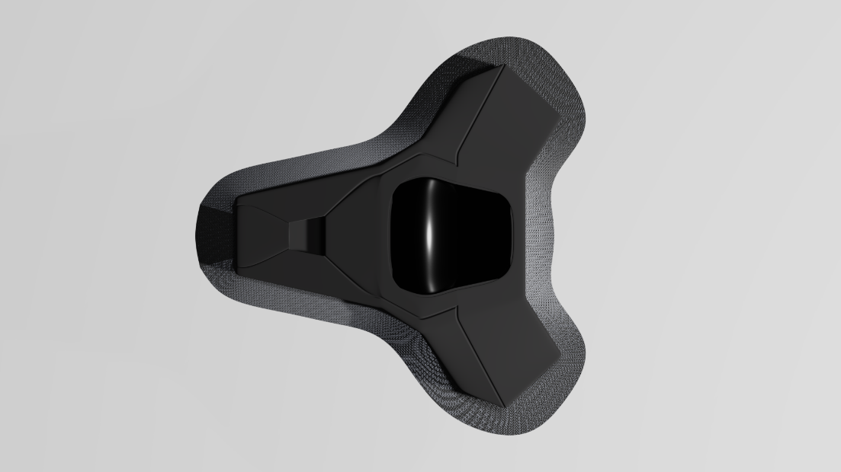

Figure 6 Render of the top view of the Smart Insulin Pump prototype

The SIP is applied to the patient's abdomen using a sticky fabric. The device features a self-injecting cannula and a suction hole for improved blood circulation and secure placement. The SIP includes a Bluetooth receiver/transmitter module that connects to both the CGM and a patient's mobile phone. A haptic motor also notifies the patient of critical events. The monitor displays glucose levels upon touch, and the device has two "horns" on the front that serve as insulin reservoirs which can be refilled via a specialized hole located on the back of the device. A charging port is also located on the front of the device (see more in Figure 12, Figure 13, Figure 14).

The RAPSC prototype design represents a novel and exciting approach to diabetes management. The closed-loop insulin delivery system aims to automate glucose control and reduce the risk of hypoglycemia. While this prototype design is not currently being evaluated, the proposed design hold potential for diabetes management, and further research is needed to evaluate its safety and efficacy before it can be brought to market.

# Implementation Report

The prototype demonstration will include the UI design of the app and 3D models of the CGM and SIP. The prototype already has a functioning AI insulin controller, which is an updated version of the implementation previously presented in my report on the Artificial Pancreas System Controller. This revised version is currently being reimplemented and tested in C++ for improved efficiency on the embedded system and will not be included in the demonstration. The demonstration will highlight the progress made on the project so far, including the gained knowledge from the successful implementation of the AI insulin controller prototype and the design of the app's front-end. It will also highlight the extensive research on diabetes, human physiology, endocrinology, and metabolism.

# Bibliography

Kolontajs, S. (2022) ‘Artificial Pancreas System Controller’. De Montfort University. Unpublished essay.

Atkinson, M.A., von Herrath, M., Powers, A.C. and Clare-Salzler, M. (2015). Current Concepts on the Pathogenesis of Type 1 Diabetes—Considerations for Attempts to Prevent and Reverse the Disease. *Diabetes Care*, [online] 38(6), pp.979–988. doi:10.2337/dc15-0144.

Bell, K.J., Smart, C.E., Steil, G.M., Brand-Miller, J.C., King, B. and Wolpert, H.A. (2015). Impact of Fat, Protein, and Glycemic Index on Postprandial Glucose Control in Type 1 Diabetes: Implications for Intensive Diabetes Management in the Continuous Glucose Monitoring Era. *Diabetes Care*, 38(6), pp.1008–1015. doi:10.2337/dc15-0100.

Cefalu, W.T., Dawes, D.E., Gavlak, G., Goldman, D., Herman, W.H., Van Nuys, K., Powers, A.C., Taylor, S.I. and Yatvin, A.L. (2018). Insulin Access and Affordability Working Group: Conclusions and Recommendations. *Diabetes Care*, [online] 41(6), pp.1299–1311. doi:10.2337/dci18-0019.

ElSayed, N.A., Aleppo, G., Aroda, V.R., Bannuru, R.R., Brown, F.M., Bruemmer, D., Collins, B.S., Hilliard, M.E., Isaacs, D., Johnson, E.L., Kahan, S., Khunti, K., Leon, J., Lyons, S.K., Perry, M.L., Prahalad, P., Pratley, R.E., Seley, J.J., Stanton, R.C. and Gabbay, R.A. (2022). 6. Glycemic Targets: *Standards of Care in Diabetes—2023*. *Diabetes Care*, [online] 46(Supplement_1), pp.S97–S110. doi:10.2337/dc23-s006.

Haidar, A. (2019). Insulin-and-Glucagon Artificial Pancreas Versus Insulin-Alone Artificial Pancreas: A Short Review. *Diabetes Spectrum*, 32(3), pp.215–221. doi:10.2337/ds18-0097.

IQWiG (2017). *Hyperglycemia and hypoglycemia in type 1 diabetes*. [online] Nih.gov. Available at: https://www.ncbi.nlm.nih.gov/books/NBK279340/ [Accessed 7 Dec. 2022].

Karamanou, M. (2016). Milestones in the history of diabetes mellitus: The main contributors. *World Journal of Diabetes*, [online] 7(1), p.1. doi:10.4239/wjd.v7.i1.1.

Kowalski, A. (2015). Pathway to Artificial Pancreas Systems Revisited: Moving Downstream. *Diabetes Care*, [online] 38(6), pp.1036–1043. doi:10.2337/dc15-0364.

KULZER, B., DOWN, S., SEIGNEZ, A., VIVES, A., BONNEMAIRE, M. and PENFORNIS, A. (2022). 925-P: European Survey on Adults with Type 1 Diabetes (T1D) and Their Caregivers: Insights into Experience of T1D Management. *Diabetes*, 71(Supplement_1). doi:10.2337/db22-925-p.

MENON, S., DESALVO, D., ERRAGUNTLA, M., PAMIDIMUKKALA, K., MCKAY, S., VILLEGAS, C. and HILLIARD, M.E. (2022). 614-P: Fear of Hypoglycemia, Hypoglycemia Confidence, and Time in Range in Adolescents and Young Adults with Type 1 Diabetes (T1D). *Diabetes*, 71(Supplement_1). doi:10.2337/db22-614-p.

Miller, K.M., Foster, N.C., Beck, R.W., Bergenstal, R.M., DuBose, S.N., DiMeglio, L.A., Maahs, D.M. and Tamborlane, W.V. (2015). Current State of Type 1 Diabetes Treatment in the U.S.: Updated Data From the T1D Exchange Clinic Registry. *Diabetes Care*, [online] 38(6), pp.971–978. doi:10.2337/dc15-0078.

National Institute of Diabetes and Digestive and Kidney Diseases. (n.d.). *Artificial Pancreas | NIDDK*. [online] Available at: https://www.niddk.nih.gov/health-information/diabetes/overview/managing-diabetes/artificial-pancreas.

PYATAK, E., SPRUIJT-METZ, D., SCHNEIDER, S., CRANDALL, J.P., PETERS, A.L., JIN, H., AGARWAL, S., PHAM, L.T., ALI, A., HOOGENDOORN, C.J., CRESPO-RAMOS, G., MENDEZ-RODRIGUEZ, H., LEE, P.-J., RUELAS, V.F., BASILE, R. and GONZALEZ, J.S. (2022). 278-OR: ADA Presidents’ Select Abstract: Impact of Overnight Blood Glucose on Next-Day Functioning in T1D. *Diabetes*, [online] 71(Supplement_1). doi:10.2337/db22-278-or.

Robertson, R.P. (2015). Islet Transplantation for Type 1 Diabetes, 2015: What Have We Learned From Alloislet and Autoislet Successes? *Diabetes Care*, 38(6), pp.1030–1035. doi:10.2337/dc15-0079.

SHAPIRA, A., VOLKENING, L.K., BORUS, J. and LAFFEL, L.M. (2020). 789-P: Self-Care for Blood Glucose Monitoring (BGM) in Teens with Type 1 Diabetes (T1D): Impact of Real-Time Positive and Negative Affect. *Diabetes*, 69(Supplement 1), pp.789-P. doi:10.2337/db20-789-p.

Veneman, T., Mitrakou, A., Mokan, M., Cryer, P. and Gerich, J. (1993). Induction of Hypoglycemia Unawareness by Asymptomatic Nocturnal Hypoglycemia. *Diabetes*, 42(9), pp.1233–1237. doi:10.2337/diab.42.9.1233.

World Health Organization (2022). *Diabetes*. [online] World Health Organization. Available at: https://www.who.int/news-room/fact-sheets/detail/diabetes.

# Appendices

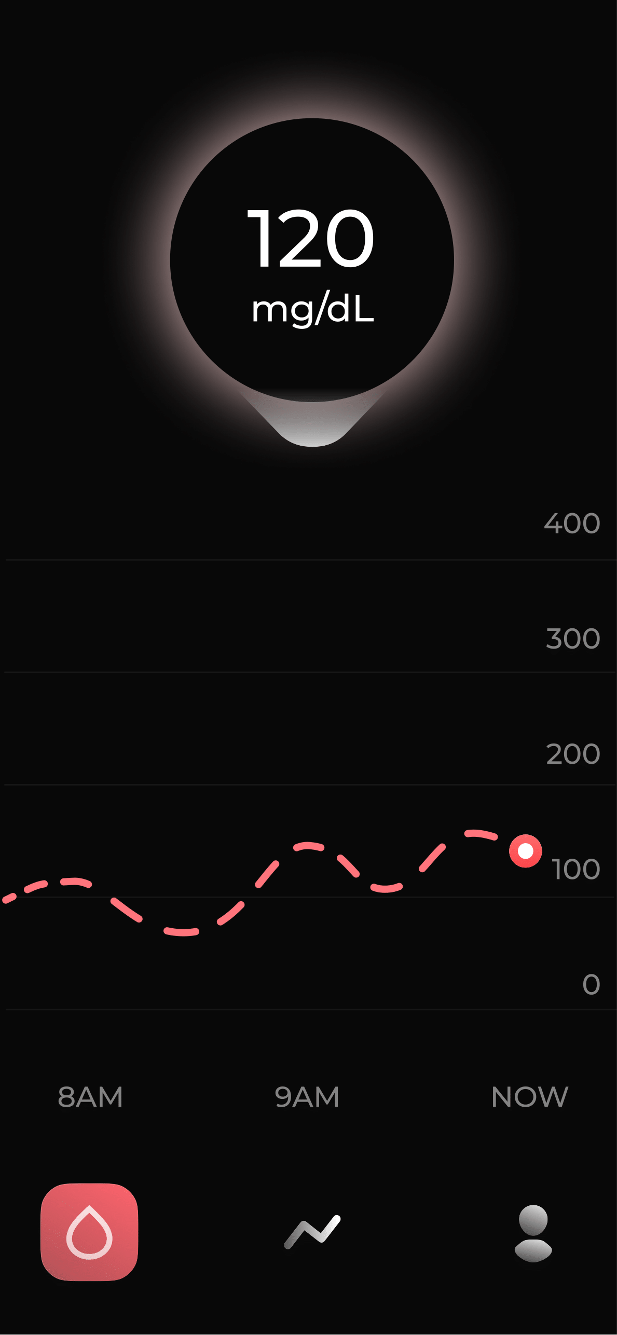

Figure 7 Virtual CGM tab in the app with real-time blood glucose tracker and trend line up showing glucose level history.

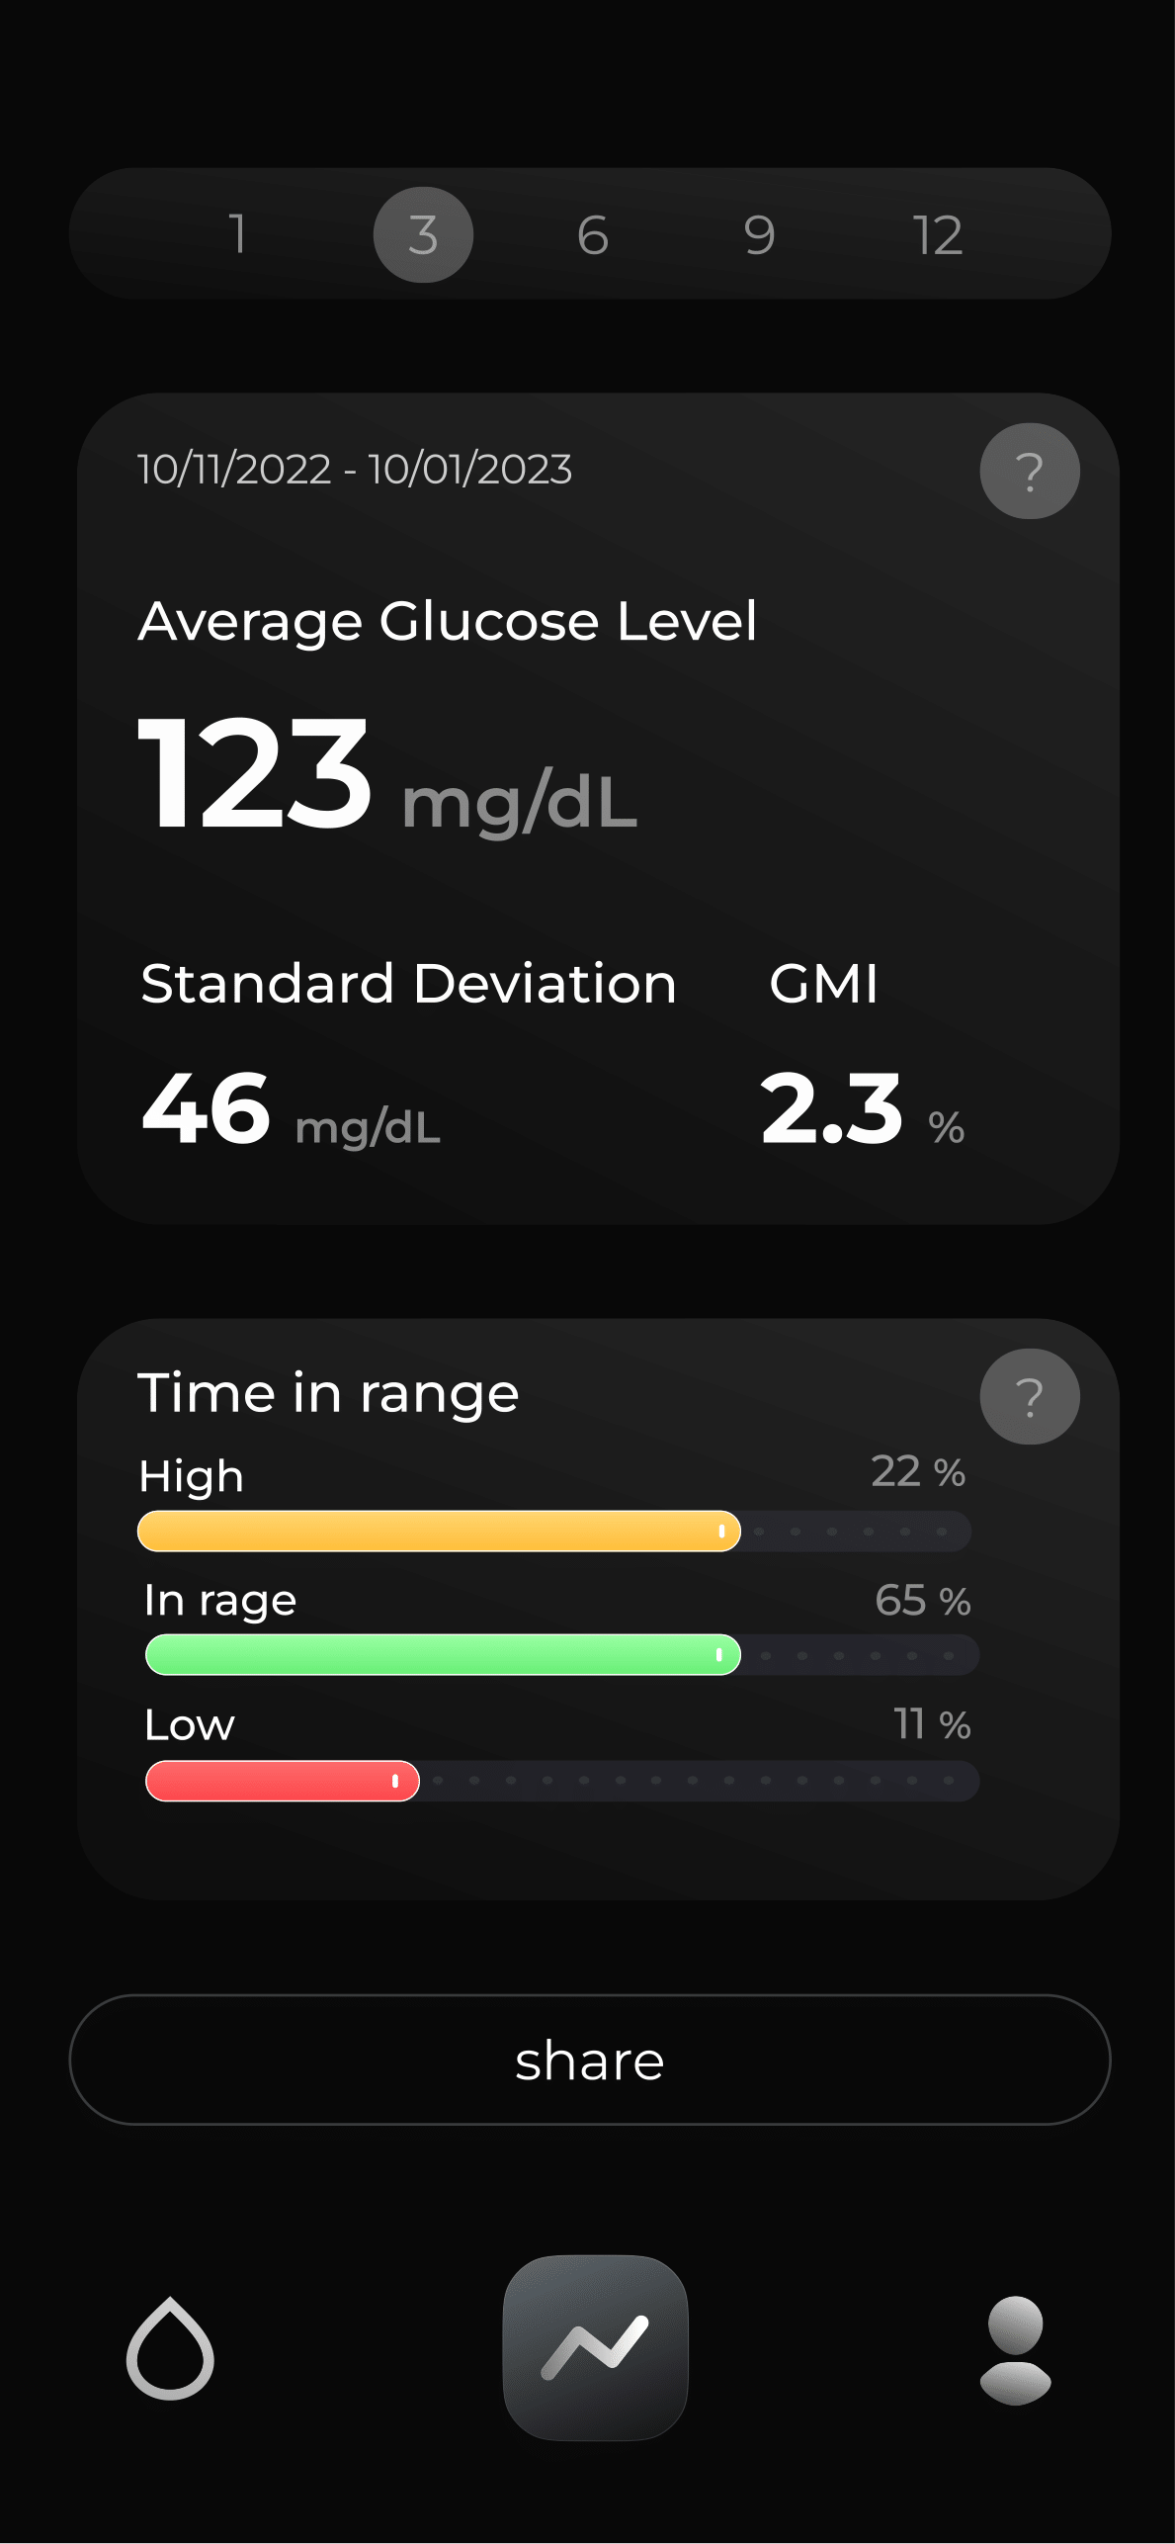

Figure 8 Statistics tab in the app showing collected data about patient within 3 months period; share button that allows to export presented data

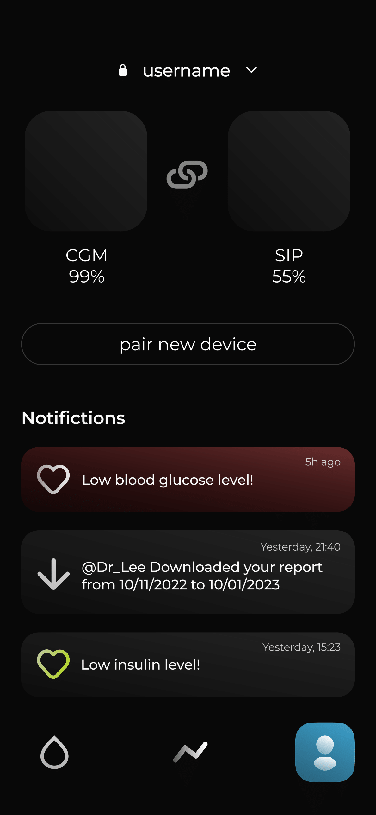

Figure 9 Profile tab in the app showing APSC devices connected to smartphone, latest notifications history as well as button to pair new device

Figure 10 Side view of the Continuous Glucose Monitor prototype render

Figure 11 Bottom side (sensor) view of the Continuous Glucose Monitor prototype render

Figure 12 Bottom side (cannula) view of the Smart Insulin Pump prototype render

Figure 13 Front side (charger) view of the Smart Insulin Pump prototype render

Figure 14 Side view of the Smart Insulin Pump prototype render

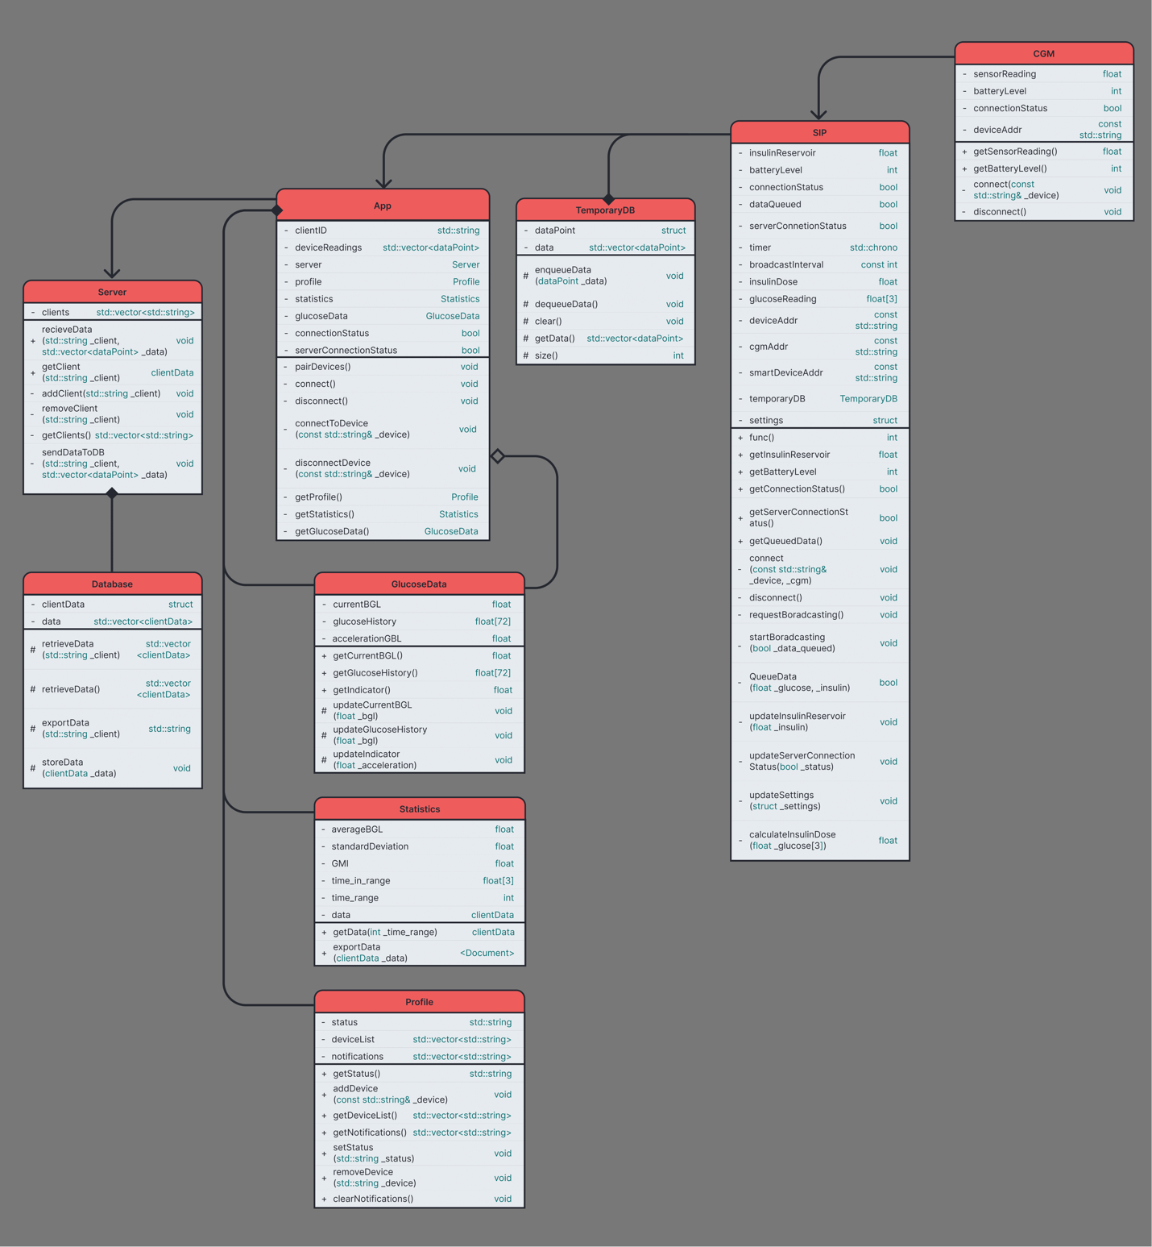

Figure 15 An indicative UML diagram for the RAPSC

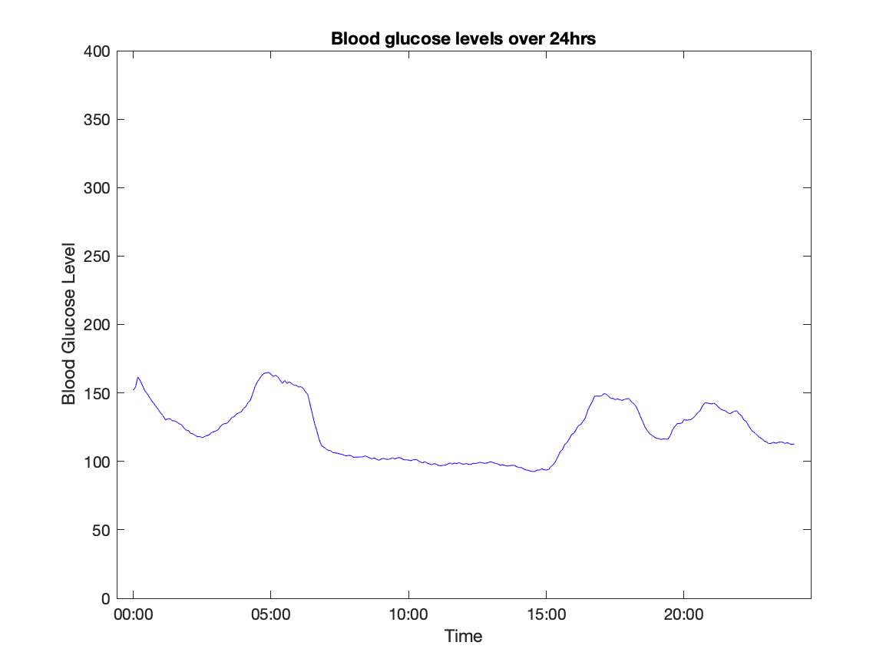

Figure 16 FTC-001 result (CGM readings)

Figure 17 FTC-002 result (CGM readings enhanced with SIP input)

|  |  |  |  |  |
| --- | --- | --- | --- | --- |
| Time | BGL | BGR | BGA | Insulin |
| 10 | 161.584341 | 1.456710045 | 0.195797243 | 0.682717382 |
| 15 | 159.184463 | -0.479975601 | -0.387337129 | 8.87944E-05 |
| 20 | 155.504806 | -0.735931396 | -0.051191159 | 7.19453E-05 |
| 25 | 151.711064 | -0.758748422 | -0.004563405 | 5.92428E-05 |
| 30 | 149.643088 | -0.413595191 | 0.069030646 | 0.01594759 |
| 35 | 146.938196 | -0.54097827 | -0.025476616 | 9.07307E-05 |

Table 1 FTC-002 partial output data

Figure 18 PTC-001 result with low blood glucose dataset (CGM readings enhanced with SIP input)

Figure 19 PTC-002 result with high carbohydrate intake dataset (CGM readings enhanced with SIP input)

Figure 20 PTC-003 result with high BGL dataset (CGM readings enhanced with SIP input)

Figure 21 PTC-004 result with very high BGL dataset (CGM readings enhanced with SIP input)

Figure 22 PTC-005 result with low carbohydrate dataset (CGM readings enhanced with SIP input)

1. Patient’s weight in this scenario is constant and equals to 69 kilograms.